Lab 2 – Testing ASP.NET Core APIs using Swagger and Postman

Learning Objectives
By the end of this lab, students will be able to:
- Understand why APIs must be tested without a frontend
- Use Swagger UI to test API endpoints
- Send GET and POST requests using Swagger
- Use Postman to send HTTP requests
- Inspect JSON responses returned from an API

Part 1 – Enabling Swagger
Modify Program.cs to enable Swagger support.
var builder = WebApplication.CreateBuilder(args);
// Enable OpenAPI / Swagger
builder.Services.AddEndpointsApiExplorer();
builder.Services.AddSwaggerGen();
var app = builder.Build();
if (app.Environment.IsDevelopment())
{
app.UseSwagger();
app.UseSwaggerUI();
}
app.MapGet("/greet", (string name) =>
{
return new
{
English = $"Hello {name}!",
Arabic = $"مرحبا {name}!"
};
});
app.MapPost("/greetpost", (NameRequest request) =>
{
return new
{
English = $"Hello {request.Name}!",
Arabic = $"مرحبا {request.Name}!"
};
});
app.Run();
public class NameRequest
{
public string Name { get; set; }
}

Part 2 – Running Swagger
Run the application and open the following URL in your browser:
https://localhost:xxxx/swagger
You will see a list of API endpoints that can be tested directly.
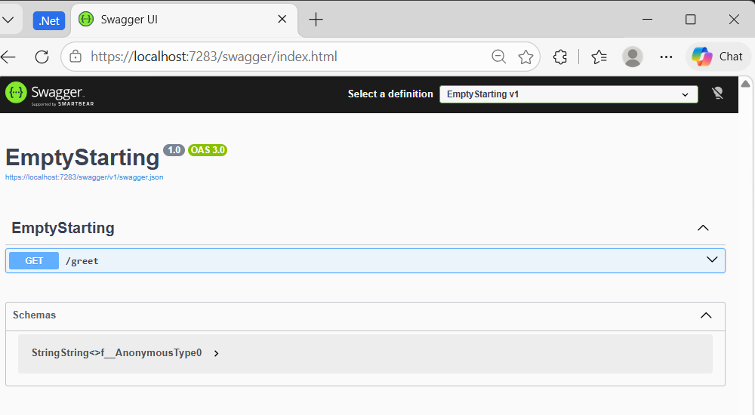
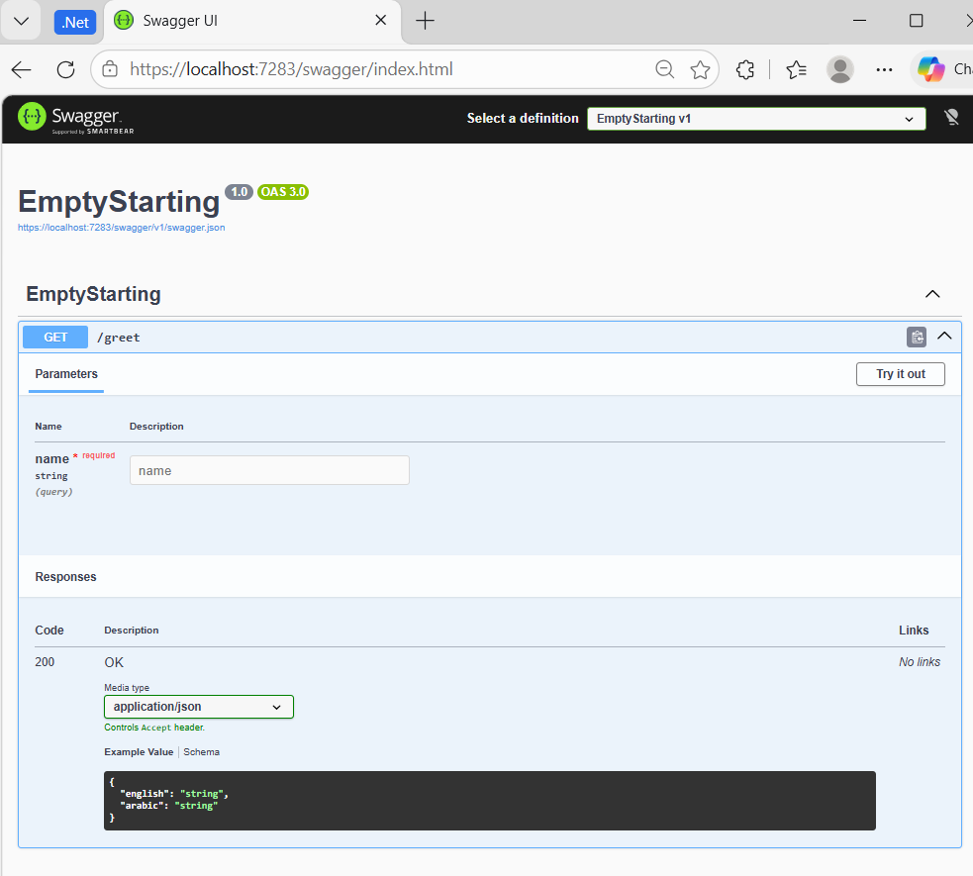
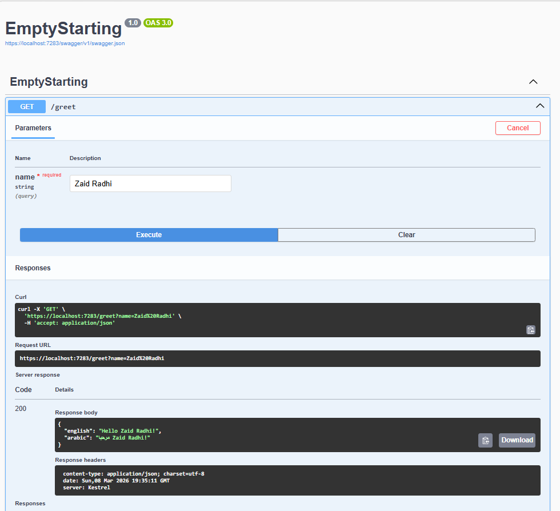

Testing the GET Endpoint
1. Expand GET /greet
2. Click 'Try it out'
3. Enter a name
4. Click Execute

Testing the POST Endpoint
1. Expand POST /greetpost
2. Click 'Try it out'
3. Enter JSON body:
{ "name": "Ali" }
4. Click Execute

Part 3 – Testing with Postman
Postman is a professional API testing tool widely used in industry.

GET Request in Postman
Method: GET
URL: https://localhost:xxxx/greet?name=Ali
Click Send to view the response.

POST Request in Postman
Method: POST
URL: https://localhost:xxxx/greetpost
Body → raw → JSON:
{ "name": "Ali" }

Student Task
Modify the API so that the response also returns the length of the name.
Example:
{ "english": "Hello Ali!", "arabic": "مرحبا Ali!", "nameLength": 3 }

